Ohio Psychiatric Physicians Foundation
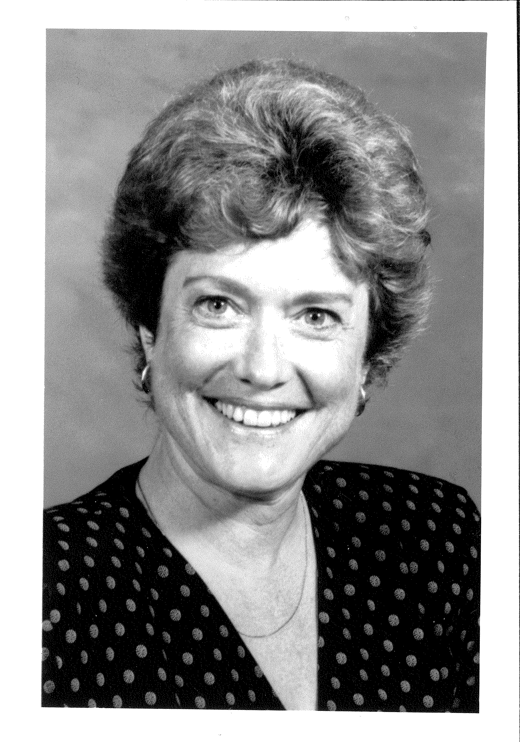

PHOTO

Janet Orttung-Morrow, MD
Child Psychiatry Memorial Fund

Janet Orttung-Morrow, MD, was a child psychiatrist with interest in developmental and psychodynamic child psychiatry issues. A beloved humanitarian and advocate, she was well-known for her willingness to stand up for the best interests of children, professional women and for the rights and needs of persons with mental disorders. She led by example and her effectiveness and advocacy was respected and appreciated. She is remembered as compassionate and kind but unswerving in her commitments.

Dr. Orttung-Morrow served the OPPA in many ways, including serving as Chair of the Liaison Committee. She was active on the Committee on Women, where she organized a child care program which was greatly needed, appreciated, and well-used by many during OPPA meetings. In addition, she served as Secretary/Treasurer and Board Member of the Foundation (when it was known as the OPA Education & Research Foundation). She also served as Secretary/Treasurer, and Board member of the Ohio Psychiatrists Political Action Committee, as well as serving as president of the Psychiatric Society of Central Ohio.

As a respected member of OPPA Council, she always provided direction toward principles and values, without offending; when she spoke others listened. Dr. Orttung-Morrow clearly believed in standing up for what was right and paying forward, whether it was through OPPA involvement, political advocacy, caring for patients, raising her two daughters by setting a strong example, or caring for her aging parents.

In January, 2011, the Ohio Psychiatric Physicians Foundation established this Memorial Fund to honor Dr. Orttung-Morrow who passed away in 1993. The OPPF is currently providing the initial funding to support a speaker at the OPPA Child & Adolescent Educational Update in the Fall of 2011.

Your tax-deductible contribution to this fund is a way you can honor the legacy of Dr. Orttung-Morrow and her commitment to serving the needs of women and children.

